Joey Scouts
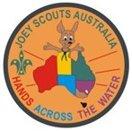 | Hands Across the Water Badge: Participate as a Mob to earn the Hands Across the Water Badge by making two overseas contacts with Joey Scout-age children, swapping Scouting items and running a typical meeting provided by the overseas Mob. (Click here for details on how to register)

CUB SCOUTS
International Culture Badge: Having a Pen-Pal is a great way to learn about a different country and what it is like to live there. What are the differences between your Pen-Pal's culture and ours?
World Friendship Badge: Get involved in JOTI - Jamboree on the Internet! This worldwide event for Scouts and Guides is held every October in conjunction with Jamboree on the Air (JOTA). This is a good time to make contact with Scouting members around the globe in a safe and supervised online environment.
Photography Badge: You could earn your Photography Badge by taking pictures of your normal meeting nights and sending them to your Pen-Pal! This is a terrific way to show them in pictures what you do at Cubs. Maybe you can encourage them to do the same and swap the Photography Badge with them.
Collector Badge: Why not get everyone to bring along their collections? Spend the night photographing and explaining each collection. Ask your Pen-Pals to do the same. It will be interesting to see the differences and similarities between your collections and those in another country.
Cooking Badge: Ask your International Pen-Pals for some traditional recipes for food from their country and have a cooking night. You could give them some recipes for Australian good, like lamingtons and Pavlova. You could even post them some Vegemite!!
Information Technology Badge: While learning about how to use a computer, have a conversation with a Cub Scout overseas for at least 20 minutes through a chat forum such as Scoutlink (www.scoutlink.net). This could be done as a whole Pack! You could do this as part of JOTI and earn your JOTA-JOTI badge at the same time.
Musician Badge: Spend an evening filming your Pack playing their musical instruments and singing songs. Perhaps some of these songs could be Australian-themed, such as our National Anthem or Waltzing Matilda. Send the film to your Pen-Pals.
Back to top
SCOUTS
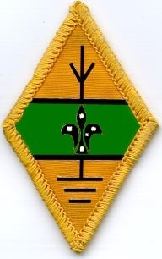 | Amateur Radio Operator Badge: While pursuing this badge, you can utilise your Pen-Pal link by making regular radio contact. This badge will need to be completed with the guidance of the Branch Jamboree of the the Air Coordinator.
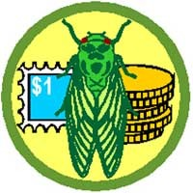 | Collector Badge: Get your whole Troop to organise their collections together, film them talking about their collections and send these to your international Pen-Pal Troop link. Have your international Troop link do the same. In this way you can see different types of collections from around the world.
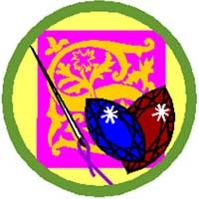 | Craft Badge: Prepare some craft items in an indigenous Australian style. Send a photo (or the craft item itself) to your international Pen-Pals, and ask them to do the same. This will allow you to experience what kind of craft is particular to each country. Why not have a go at some craft in the style of the indigenous people in your Pen-Pal's country?
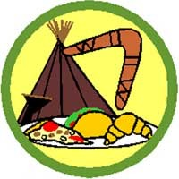 | Cultural Heritage Badge: Identify and try food from a different culture or country. Prepare and cook a three-course meal inspired by a different culture or country. Find out about indigenous Australian traditions and ways of life, then make a film about it and send it to your Pen-Pal.
 | Multi Media Badge: Why not design a website or Powerpoint presentation about your Troop for your new international Troop link? A website could be a great way for members to communicate. You could even use Facebook!
 | Information Technology Badge: Use the internet to find out information about Scouting in your Pen-Pal's country. Many countries have a national Scouting website, or your Pen-Pal's Group may have a website of its own. Learn how to build a website or create a Powerpoint presentation. Create one for your international Troop link.
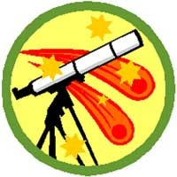 | Astronomer Badge: Know the location of two constellations in your area of the world. Find out what your Pen-Pals can see. Are the constellations they can see the same as the ones you can see, or are they different? Can you see the same constellations as your Pen-Pal but at different times of the year?
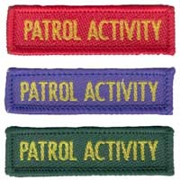 | Patrol Activity Badges: Each Patrol can take a turn to organise and run an international night where they decide on a new or different way to communicate with your Troop's international Pen-Pal link.
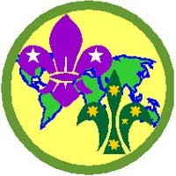 | World Scouting Badge: Ask your international Pen-Pal about the kinds of activities they do. Which activities are the same, or similar, to activities you do? Are there any that are very different? Maintain regular correspondence with a Scout in another country and report on what you find out about Scouting.
Back to top

VENTURER SCOUTS
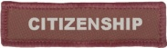 | Venturer Award - Citizenship: Contact a Venturer Scout overseas and exchange at least three letters/emails from each person discussing aspects of local community life and your personal involvement.
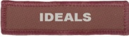 | Venturer Award - Ideals: Through letter/email/chat conversations with a Venturer Scout overseas:  a) explore moral, social and religious customs and teachings, and compare them to your own, in order to better understand your own relationships with other people.  b) explore moral, social and religious customs and teachings, and compare them to your own to discover for yourself what is involved in your acceptance of the Promise and Law.
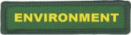 | Queen's Scout Award - Environment + World Scout Environment Badge: A1. With a Venturer Scout overseas, collaboratively research (using a Wiki) the sources of clean water and clean air in your own local environments. Through collaboration, you will be able to compare the quality of both the air and water in your local area, along with the associated pollutants which need identifying and addressing, much more easily.  A2. Share resources and information about global conservation issues affecting biodiversity with a Venturer Scout overseas.  A2. Select a common ecosystem that both you and a Venturer Scout overseas share, and collectively demonstrate through written and visual means, the ecosystem connections of native species of plants and animals and their habitat needs.  A3. Having identified the local impact of harmful substances to people and the broader environment in A1, design solutions or strategies for what can be done by individuals, groups and the community to reduce the risk.  A3. Share resources and information about the global impact of harmful substances and how local actions can chage the global environment with a Venturer Scout overseas.  A4. Having established issues and possible solutions with a Venturer Scout overseas, explain how the choice of action and responsibility as an individual, group, community and country can affect the environment.  A4. With a Venturer Scout overseas, have conversations (via letter/email/chat) that further develop your understanding of how we can change our actions to improve our impact on the environment.  A4. If you have provided a local solution to a problem, share this with a Venturer Scout overseas in order to demonstrate to them how local solutions can impact global issues. Imagine your successful solution was implemented all over the world and you became partly responsible for saving a species!  A5. Collectively research with a Venturer Scout overseas, and share your findings with others in relation to recognising different types of environmental hazards and natural disasters, and being able to explain why they occur.  A5. Collectively research with a Venturer Scout overseas, and share your findings with others in relation to explaining how changes to the environment can influence environmental hazards and natural disasters.  B. Design and lead an environmental project which relates to the learnings obtained from some of the completed activities. Share the progress of your project with a Venturer Scout overseas. Continual conversations with others, particularly from different backgrounds, usually leads to new ideas being posed that you would normally not pose yourself. This is tremendously helpful when conducting such projects.  Queen's Scout Award - Ideals: Make contact with District/Region Scouting Staff and with equivalent people overseas (or via your penpal as JOEY SCOUTS

