LEADER TRAINING

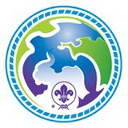 | 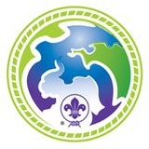 | 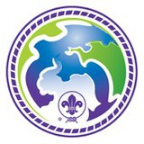
World Scout Environment Badge (WSEB) Program Weekend

The program covers the knowledge, of all of the five sections, required to complete Part A of the WSEB at the three levels. The course also includes activities and games to complement the WSEB program. A wide range of age appropriate activities and games resources, are provided, to be integrated into youth meetings.

Weekend program:
- Saturday (8.30am) to Sunday afternoon
- Participants can arrive on Friday evening.

