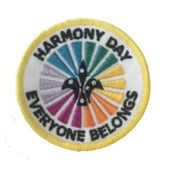 | 2018- HARMONY DAY  ACTIVITIES FOR QUEENSLAND SCOUTS  CUB SCOUTS AND CYBER-SAFETY

The project
As part of the World Movement of Scouting, Scouts Australia celebrates Harmony Day annually. March 21 is Australia's Harmony Day, and at this time we celebrate our country's cultural diversity and belonging. Sometimes the celebrations can be held over the week that includes this date.

The message of Harmony Day is ‘everyone belongs’. It aims to engage all people to participate in their community, respect cultural and religious diversity and foster a sense of belonging for everyone. Scouts can celebrate our diversity and belonging by participating in a special section meeting that focuses upon the themes of Harmony Day. This could be incorporated as part of Messengers of Peace activities or other aspects of the Award Scheme. For 2018 we are encouraging the ‘sense of belonging’ through focussing on cyber safe activities. We encourage you to share discussions in your section regarding cyber safety and ‘netiquette’. You may like to engage in our suggested programs or with the youth members make up a fun night’s activities of your own.

Participation in this or a similar activity enables the youth and leader to wear the Special Harmony Day Badge available from the Scout Shop. Make sure you get these badges in advance so they can be awarded at the end of the activity.
https://scoutshop.com.au/products/2018-harmony-day-badge

Why Cybersafety?
Australia is one of the most connected and engaged countries in the world. While social media has great benefits it can also have some disadvantages including isolating some members of our families, our friends and it creates victims who feel there is nowhere to go to get away from hardships. It is reported that 1 in 8 Australians experience cyber bullying and it is now the second most common form of bullying in Australia. It is intergenerational so anyone can be a victim or a bully, whatever their age. Young people often don’t tell adults about cyberbullying because they fear they will be cut them off from their friends and family.

To assist and create awareness, these short programs, focus on the importance of our belonging as a member of Australia and encouraging our youth members to be responsible and safe users of technology. The programs have been written deliberately avoiding the use of internet and the need to be on-line. Of course they should not be a one-off experience but these issues should be incorporated into other weekly programs throughout the year.

POSSIBLE CUB SCOUT PROGRAM
- Use these as ideas
- Where ever possible see if some of the young people can lead some of these games.
00. | Opening Parade, messages
05 | Game: Colours  Allocate the colours red (strength), blue (trust), green (acceptance) and white (safety) to each of the 4 walls and orange at the centre of the scout hall. Leader of the game (may be youth or adult) calls out colours randomly and gets youth members to run to that area. After a few quick calls, the Pack ends up at orange with youth sitting in centre.  Adult talks briefly about colours and why orange is important at this meeting. Refer Session Aid 1. Establish it represents Harmony Day. Discuss what that means- leaving together in harmony, respecting differences, cultural diversity and belonging to our community and Australia and world. (Orange is the colour chosen to represent Harmony Day. Traditionally, orange signifies social communication and meaningful conversations. It also relates to the freedom of ideas and encouragement of mutual respect and belonging.) Discuss the meaning of other colours also. Show badge and explain how they can wear this on their uniform.
0.12 | Activity and discussion; How we use technology  Each Six is given a sheet of chart paper and each member has a different coloured pen. As a Six, they must draw examples of how and why we use computers and technology in our lives. One member from each Six shows their poster and explains their different ideas to others. Display the charts.
0.17 | Pack Discussion  As a Pack, Leader gets youth members to summarise these uses and why it is important we follow rules so we are safe when using the net. It is called cyber-safety. We are going to consider “Neti-quette’ or etiquette (good manners) when using the internet”. See ideas on Session Aid 2. Reinforce SMART acronym.
0.22 | Activity- Youth leading youth- Thinking about safety  Ten numbered questions are printed out and two are given to each Six. Refer Session Aid 3. They must consider the answer to these two questions. They can discuss the reason for their answer as a Six and keep their answer to themselves.  Questions:  - Information you find on the internet is always true. No  - You are having trouble doing an activity on a safe site you use at school. Your friend offers to help but needs your password. Would you give your password? No  - Your parents want to know what you have been doing on a safe site you use at school. Would you let them use your account?. Yes and you should be with them to explain what you have done  - Should you meet with someone you have only met on line, even if they say you are a friend. No  - You should only use your user name and not your real name when going on line. Yes  - It is polite to share your email address, name and home address and photos with people you meet on line. No  - You should never open files or pictures or messages from people you don’t know. Yes  - It’s okay to be rude and awful on the internet because no one can see you. No  - It is ok if someone is rude to you on the internet or Face book because this is not real. No  - If something worries you on the internet, turn it off quickly. No. Go straight to your parents or an adult and show them the screen page.
0.27 | Personal Quiz Game  Each question is then asked one at a time, by a member of each Six to all members. All members must answer these questions by moving to left of Scout Hall for No, right for Yes or in centre of room for Unsure. The person asking each question then advises rest of Pack of the answer that their Six selected and why. If necessary the adult could assist with the discussion.  To make the game more challenging the youth can be encouraged to move to the area by using different animal ways e.g. as an elephant, monkey, slow like tortoise, fast like a rabbit, tall as a giraffe, strong like a Superhero, jerky like a robot..
0.42 | Six Scenario  Each six is asked to think about how act they would respond to this situation: Your best friend tells you the secret that they are getting bad messages when they are on line. They are worried that their parents will stop them using this. What do you tell them to do? The Six discuss this and share ideas.
0.55 | At least two people in each Six then act out what could be said. Adult and Pack watch each role play and leader reinforces appropriate responses: Important message- don’t respond to the bad message, this is bullying, tell an adult- parent or teacher or scout leader.
1.05 | Cyber-safety and Scout Law  Leader asks Cub Scouts to consider new Scout Law. Have the Poster available. See Session Aid 4.  What aspects of the parts of the Scout Law do the Cub Scouts think that relates to safe use of the Internet or ‘Netiquette’. Discuss. Refer Session Aid 5 for assistance.
1.15 | Leader gets youth to review the Pack Code of Behaviour as agreed last year. Are there any changes that should be made? Once agreed each member will be asked to renew their agreement to the Pack Code of Behaviour. (This may be signed at next meeting).
1.25 | Prepare for final parade. Present Harmony Badges available from Scout Shop. https://scoutshop.com.au/products/2018-harmony-day-badge
1.30 | Close of meeting

Session Aid 1
COLOURS

Traditionally, Orange signifies social communication and meaningful conversations. It also relates to the freedom of ideas and encouragement of mutual respect and belonging. It is the universal colour for Harmony Day.

Red is the colour of fire and blood, so it is associated with energy, war, danger, strength, power, determination as well as passion, desire, and love. STRENGTH

Green is the colour of nature. It symbolizes growth, harmony, freshness, social, nature, acceptance and fertility. Green has strong emotional correspondence with safety. Dark green is also commonly associated with money. ACCEPTANCE

Blue is the colour of the sky and sea. It is often associated with depth and stability. It symbolizes trust, loyalty, wisdom, confidence, intelligence, faith, truth, and heaven. TRUST

White is associated with light, goodness, innocence, purity, and virginity. It is considered to be the colour of perfection. White means safety, purity, and cleanliness. As opposed to black, white usually has a positive connotation. White can represent a successful beginning. In heraldry, white depicts faith and purity. SAFE

Session Aid 2
Session Aid 5
NET-IQUETTE - CYBERSAFETY RULES
Be SMART on the Internet:
S | SAFE  Keep safe by being careful not to give out personal information- such as full name, address, password, email address, telephone number, school name, scout group to people you are chatting with on line..
M | MEETING  Meeting someone you have only been in touch with online can be dangerous. Only do so with your parents’ or carers’ permission and then only when they can be present.
A | ACCEPTING  Accepting emails, messages or opening files, pictures or texts from people you don’t know or trust can lead to problems- they may contain viruses or nasty messages!
R | RELIABLE  Someone online might like about who they are, and information on the internet may not be true. Always check information with other websites, books or someone who knows.
T | TELL  Tell your parent, carer or trusted adult if someone or something makes you feel uncomfortable or worried, or if you or someone you know is being bullied. You should report abuse.
Acknowledgements: Childnet International- www.childnet.com; www.kidsmart.org.uk
(Great poster on this available to download)

Session Aid 3
QUESTIONS
- Is Information you find on the internet always true.

- You are having trouble doing an activity on a safe site you use at school. Your friend offers to help but needs your password. Would you give your password?

- Your parents want to know what you have been doing on a safe site you use at school. Would you let them use your account?

- Should you meet with someone you have only met on line, even if they say you are their friend?

- You should only use your user name and not your real name when going on line.

- It is polite to share your email address, name and home address and photos with people you meet on line

- You should never open files or pictures or messages from people you don’t know.

- You can be rude and awful on the internet because no one can see you.

- It is ok if someone is rude to you on the internet or Face book because this is not real.

- If something worries you on the internet, turn it off quickly.

Session Aid 4
SCOUT LAW POSTER
(refer separate PDF available )
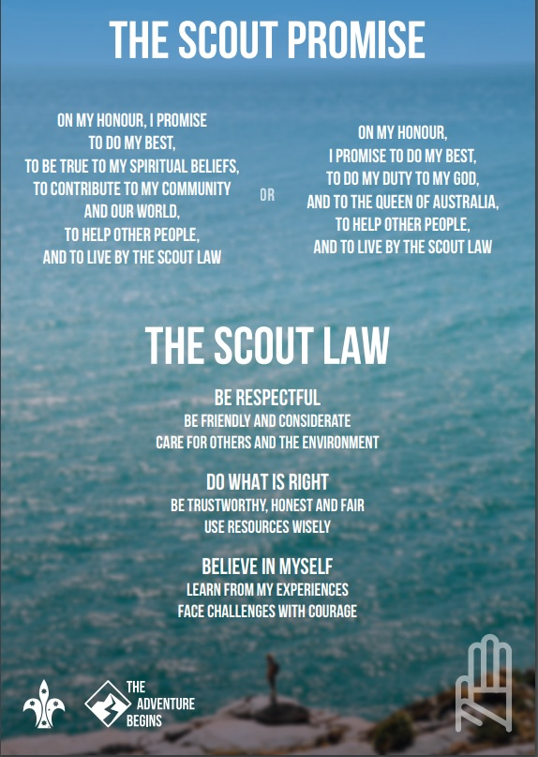

Session Aid 5
OUR SCOUT LAW AND CYBERSAFETY
We are online a great deal to do our work and also to keep in touch and have fun. Using technology enables us to be more effective in what we do. It saves us time with research, helps us connect with others and to have fun. But what does living in the digital world and to us as Scouts and how we live by the Scout Law? Here are some thought starters.

- Be Respectful | Consider the needs and wishes of others at all time  Treat others as you would wish to be treated
- Be friendly and considerate | Do the right thing when sharing other people’s words or pictures.  Be polite and respectful.
- Care for others and the environment | Alert others to scams, cheats, and suspicious sites.  Point them to reliable and accurate sources of information.  Look out for friends who may be being bullied  Support people who are being bullied
- Do What is Right | Reach out to support others who are doing good things, like posting quality creative works.  Support those who are bullied.  When using digital devices, follow the rules set by your parents/guardians, teachers, and Scout leaders.  Keep the rules made by sites, services, devices, and games.
Be trustworthy, honest and fair | Be truthful with others online  Be very careful of the information you share.  Make sure you have the owner’s permission before using other people’s work  Share information about others only if you have their permission  Uphold appropriate agreements you make with friends when you play games with them.  Treat people with respect when you are on social networks, playing games, talking or texting on a mobile phone, or in other digital activities.
- Use resources wisely | When you use other people’s work, be sure to ask permission.  Follow fair use standards  Give credit to the people who created and own the work. Use games, messaging tools, and social forums to build your relationships with others while having fun.  Be a smart consumer.  Know your voice, text and data plans and use them wisely  Be sure to study digital devices and services you want.  Before buying them, make sure you’re not overspending on functions and features you won’t need.  Be careful not to run up charges on apps and sites.
- Believe in Myself | Stand up for what you know is right.  Do not participate in mocking and bullying others, even if your friends are doing it.  Report suspected abuse to a trusted adult, like your parent or leader;  If the incident involves any part of the Scouting program, tell your leader immediately.
- Learn from my experiences | Remember what you have learnt and share this with your friends  Share new ideas with your friends  Discuss ideas with friends and others so you can improve your skills and knowledge.
Face challenges with courage | Encourage people to report bad behaviour online. Respect the feelings of other people.  Do not use digital devices to spread inappropriate or unkind ideas.

Session Aid 6

FURTHER ASSISTANCE

Assistance for youth
Youth can contact Kids Helpline 24/7 for confidential support.

Internet Safety Resources
Office of the Children’s eSafety Commissioner; https://esafety.gov.au/

Selfies: http://www.police.qld.gov.au/programs/cscp/personalSafety/children/childProtection/sexting.htm

Think You Know:
http://www.thinkuknow.org.au/

Join the Dots
http://www.bravehearts.org.au/join-the-dots/

Who’s Chatting To Your Kids
http://www.police.qld.gov.au/programs/cscp/personalSafety/children/childProtection/

