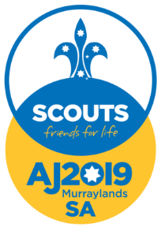

Dear Scouts and Parents

What is the Australian Jamboree? Well, it's only the biggest and best event in the Australian Scouting calendar. So big in fact, that it only runs every three years!

This is the biggest event in a Scout’s life and the next one is going to happen in January 2019.

Over 10,000 Scouts from all over Australia (and even some internationals) will converge on The Bend Motorsport Park in Tailem Bend, South Australia for 10 glorious days of fun, fantastic adventure and friendship and we have less than 690 days to go.

We will be running an information session on XXXX XXXX 2017, at 7:00pm at the Den to talk about a Jamboree as an event and to start getting ourselves organised.

Those who will be Scouts in January 2019 will be eligible, so this invitation is to our older Cub Scouts and existing Scouts.

It is important you make it to the meeting to find out more, particularly how to make it as easy as possible for your Scout to attend. If you need more information before the meeting please get in touch of course.

Yours in Scouting

Scout Leader
Email..

