Merchandise order form
First Name
Please print clearly
Surname
Cub Pack/Scout Group |  | Date of Order
Delivery Address
Suburb |  | State |  | Postcode
Daytime contact Number:
Mobile Number
Email address
Towel $16.00 each (GST included)  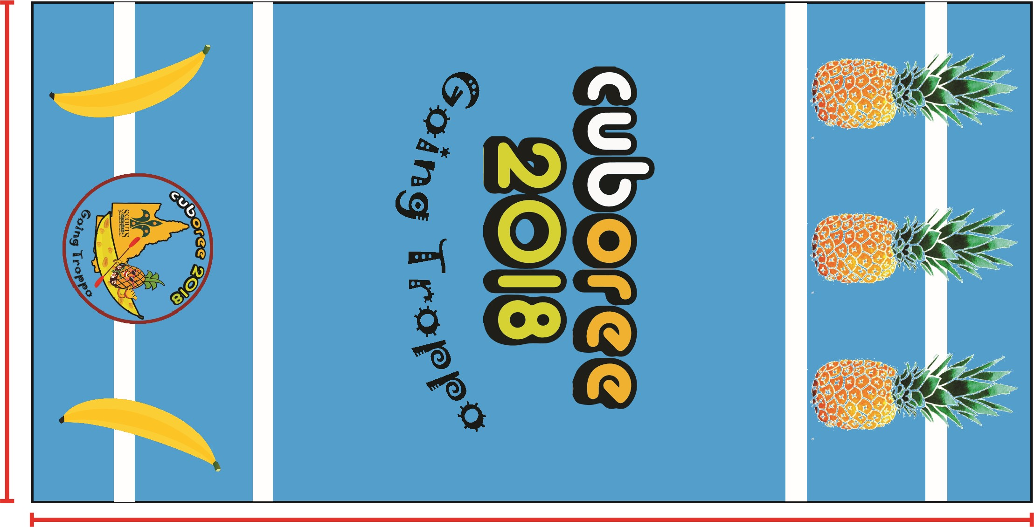  Printed Beach Towel  150 cm x 75 cm  The back of the towel includes a place to write your name/s. |  | Number of towels:  @ $16.00 = $
# Aust. Post Charges (incl GST) - Pre-Paid Postage Bags (with tracking)  1 x Towel: $11.00  2 x Towels: $15.00  More than two towels TBA |  | Plus postage  $
TOTAL PAYABLE:  Equals the $ amount of towels ordered plus relevant postage |  | $
Payment Method: Please circle one *Direct Deposit **Cheque
*Direct Deposit Bank Details:
- Account Name: Scouts Ass of Aust Qld Branch t/a Cuboree
- BSB: 034 - 010
- Account: 287119
- Reference: MERCH [surname, first initial]

*Direct Deposits: Please email this form, your date of deposit, the amount of your payment and your reference to: sales.cuboree@scoutsqld.com.au

**Cheques: Please post your cheque along with this order form to:
Scouts Assn of Australia Qld Branch t/a Cuboree
PO Box 520 TOOWONG DC, QLD 4066

Office use
Receipt No |  | Amount $ |  | Tracking #

