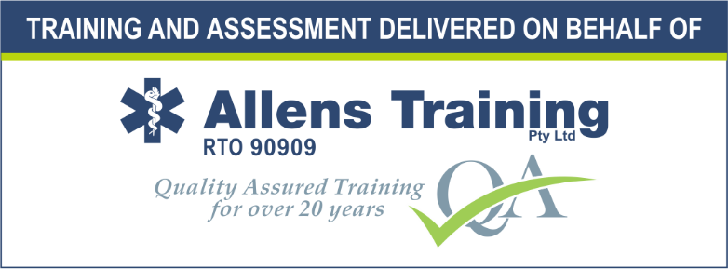

First Aid Training:

HLTAID001 Provide Cardiopulmonary Resuscitation

This course provides you with the skills and knowledge to recognise when someone is unconscious and not breathing normally (Cardiac Arrest) and increase their chance of survival by calling an ambulance and performing potentially lifesaving cardiopulmonary resuscitation (CPR), including using a defibrillator, until emergency services arrive to take over.
The course is delivered in line with the Australian Resuscitation Council guidelines and applies to all workers or members of the community who may be required to provide CPR in the event of an emergency.

PROVIDER OF TRAINING AND ASSESSMENT
This course is delivered and assessed on behalf of Allens Training Pty Ltd RTO 90909 by Scouts Queensland.
IMPORTANT INFORMATION PRIOR TO ENROLMENT
Unit Being Delivered
The following unit will be awarded to successful participants in this course. The certificate will be issued by Allens Training Pty Ltd RTO 90909.
• HLTAID001 Provide Cardiopulmonary Resuscitation
To view full unit details please visit www.training.gov.au
Course Duration - Blended delivery – 3 hours face to face course – after completing the self-paced learning at least 1 week prior to attending the face to face course
Learners Rights, Responsibilities and Support, including Complaints
Please note that enrolment to this course is made with Allens Training Pty Ltd RTO 90909. Please refer to the student handbook located on the RTO website https://www.allenstraining.com.au/students/student-handbook.aspx for all details relating to rights and responsibilities including complaints and appeals.
Course Fees and Payments
• Please refer to the back page of training application form (A15FA) for relevant course fees.
• Refund and fee protection policy – more than 7 days prior to the course a full refund, 7 days or less an administration fee will be charged, non-attendance at course no refund.
• Payment Terms – payment needs to be made at time of submitting the training application
Physical Requirements
Participants must have the physical capacity to perform 2 minutes of uninterrupted CPR on an adult on the floor. There can be no exceptions to these Australian Government requirements that are clearly written into the Training Package. Therefore, students who are unable to satisfy the physical requirements of the course cannot be deemed competent or issued with a statement of attainment, even if the qualification is a necessary part of their employment conditions.
Assessment Requirements
Individuals undertaking this course will be expected to complete both written and practical assessment tasks. These are detailed in the sections following.
What happens at the course?
Assessment Activities
- Assessments conducted during face-to-face training session(s) include:
  - Practical scenarios – The assessor must observe the following practical scenario:
    - Perform CPR on an adult for 2 minutes on the floor.
    - Perform CPR on an infant.
  - Theory assessment – A written assessment consisting of multiple-choice questions. The student must successfully complete all assessment questions.

