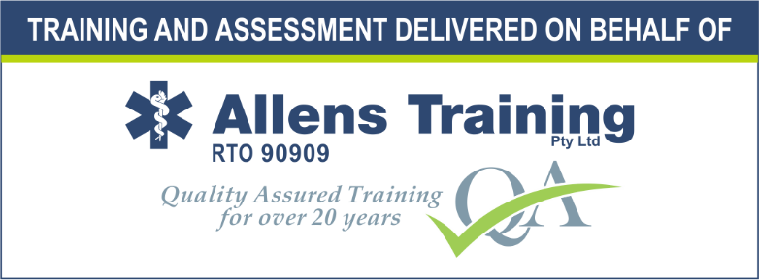

First Aid Training:

HLTAID003 Provide first aid

This first aid course will allow you to develop skills and knowledge and most importantly, confidence, to provide first aid treatment to any person suffering a sudden illness or injury. You will develop the skills to preserve life, prevent the condition from worsening, and promote recovery. It includes initial intervention in a casualty with a serious condition prior to professional medical help being available, such as performing CPR while awaiting an ambulance, as well as the complete treatment of other less serious conditions, such as applying water for burns, or assisting someone choking.
Providing effective, lifesaving first aid interventions requires instruction and practical training. This is especially true where it relates to potentially fatal illnesses and injuries, such as those that require cardiopulmonary resuscitation (CPR) or involve severe bleeding. These procedures carry a risk of further injury to the casualty and the first aider. As with any training, it is more useful if training occurs before being confronted with an actual real-life situation.
The course is delivered in line with the Australian Resuscitation Council guidelines and applies to all workers or members of the community who may be required to provide CPR in the event of an emergency.
This first aid course is essential for everyday life events, allowing you to provide immediate and effective first aid to workers or others who have been injured or become ill at the workplace or at home.

PROVIDER OF TRAINING AND ASSESSMENT
This course is delivered and assessed on behalf of Allens Training Pty Ltd RTO 90909 by Scouts Queensland.
IMPORTANT INFORMATION PRIOR TO ENROLMENT
Unit Being Delivered
The following unit(s) will be awarded to successful participants in this course. The certificate will be issued by Allens Training Pty Ltd RTO 90909.
- HLTAID003 Provide first aid
- HLTAID002 Provide basic emergency life support
- HLTAID001 Provide Cardiopulmonary Resuscitation
To view full unit details please visit www.training.gov.au
Course Duration - Blended Delivery – 8 hours –face to face course – after completing the self-paced learning at least 1 week prior to attending the face to face course
Learners Rights, Responsibilities and Support, including Complaints
Please note that enrolment to this course is made with Allens Training Pty Ltd RTO 90909. Please refer to the student handbook located on the RTO website https://www.allenstraining.com.au/students/student-handbook.aspx for all details relating to rights and responsibilities including complaints and appeals.
Course Fees and Payments
• Please refer to the back page of training application form (A15FA) for relevant course fees.
• Refund and fee protection policy – more than 7 days prior to the course a full refund, 7 days or less an administration fee will be charged, non-attendance at course no refund.
• Payment Terms – Payment needs to be made at time of submitting the training application
Physical Requirements
Participants must have the physical capacity to perform 2 minutes of uninterrupted CPR on an adult on the floor. There can be no exceptions to these Australian Government requirements that are clearly written into the Training Package. Therefore, students who are unable to satisfy the physical requirements of the course cannot be deemed competent or issued with a statement of attainment, even if the qualification is a necessary part of their employment conditions.
Assessment Requirements
Individuals undertaking this course will be expected to complete both written and practical assessment tasks. These are detailed in the sections following.
What happens at the course?
Assessment Activities
- Assessments conducted during face-to-face training session(s) include:
  - Practical scenarios – The assessor must observe the following practical scenario:
    - Preform CPR on an Adult
    - Preform CPR on an Infant
    - Anaphylaxis & autoinjector
    - Asthma & medication
    - Choking
    - Turn a casualty on his/her side
    - Bleeding control & shock
    - PIT for a snake/spider bite
    - Rice for sprain
- Theory Assessment – A written assessment consisting of multiple-choice and short answer questions. The student must complete all assessment questions

