**Special Interest Area badges youth members can achieve, supported by Queensland Environmental Education Team:**

***Joey Scout SIA Badges (2 hours each badge)***



*On a full day program, Joey Scouts can earn two Environment badges or one Environment and one Innovation & Stem.*

**\*** It is suggested, that some 5 year olds, not in Prep, only attend for one 2 hour badge.

*Other Environmental Programs for Joey Scouts*

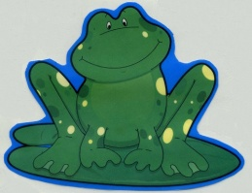Eprapah also runs a **Frog and Water** activity day, as an introduction to the Cub Scout World Scout Environment Badge*.*

***Cub Scout SIA Badges (4 hours each badge)***



On a full day program, Cub Scouts can earn only one badge

*Other Environmental Programs for Cub Scouts*



**World Scout Environment Badge**

* **10 hours in total**

***Scout SIA Badges (8 hours for each badge)***

Includes Sustainable Development Goals (SDG)



*This SIA badge is awarded on the completion of the*

*World Scout Environment Badge*

*at Scout level*

*On a full day program Scouts can earn the Environment badge*

Activity day program can include:

* Aquatic animal survey – SDG Life under Water (14)
* Water quality in natural systems – SDG Clean Water (6)
* Pressures on waterway health – SDG Responsible Consumption (12)
* Vegetation and Soils – SDG Life on Land (15)
* Tree planting – for a better world – SDG Life on Land (15)

*Other Environmental Programs for Scouts*

**World Scout Environment Badge**

* **15 hours in total**

***Venturer Scout SIA Badges (12 hours each badge)***

IncludesGlobal Sustainable Development Goals (GSDG)



*On a full day program, Venturer Scouts can be credited with 8 hours toward earning their Environment SIA badge*

*This SIA badge is awarded on the completion of the*

*World Scout Environment Badge*

*at Venturer Scout level*

Venturer Scout day programs available:

**Bushland** –SDG – Life on Land (15)

Activities covered:

* Participate in a sustainability activities
* Undertake soil composition and structure activities
* Re-vegetate a bushland area

**Catchment-care**-SDG – Life under Water(14)

Activities covered:

* Participate in a sustainability activities
* Undertake aquatic life surveys and water quality test activities
* Re-vegetate a riparian area

**Marine** – SDG – Life on Land (15), Life below Water (14), Climate Action (13)

Project: To study the impact of people on the sea

Activities covered:

* Examine different types of shoreline, sandy, rocky and mangrove
* Identify plants & animals in those areas
* Observe human use/ damage in these areas & learn how this can affect marine ecosystems

*Other Environmental Programs for Venturer Scouts*

**World Scout Environment Badge** at Queens Scout Award level

* **30 hours total**

***Rover Scout SIA Badges (18 hours each)***





*This SIA badge is awarded on the completion of the*

*World Scout Environment Badge*

*at Rover Scout level*

On an extended weekend - activities for a SIA ENVIRONMENT:-

Activities include group discussions/brainstorming

* Word terms game
* Landcare
* Waterwatch
  + Endangered species
  + Weedbust
  + Scouts Australia
  + Birdwing Butterfly Recovery Program
  + Aboriginal Culture Programs
  + Law interpretation activity
  + Local history experience
  + Biodiversity



**World Scout Environment Badge** at Baden-Powell Scout Award level

* **30 hours in total**

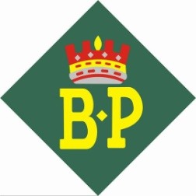

The **Community Development Badge** can also be carried out at Eprapah.

There are other service projects available for crews and individuals at Eprapah SCENE site.