Ready Set SCOUT! Social Media Text
Copy and paste the corresponding caption as you schedule each week’s Ready Set SCOUT! posts on your Scout Group’s public facing Social Media platforms according to the Ready Set SCOUT! Calendar.
Follow the ‘How to’ guides for further assistance.
Post | Caption
6pm Wednesday 27 January | From as young as 5 years old, Scouts have a world of opportunities at their fingertips! #ReadySetScout #Archery #JoeyScouts
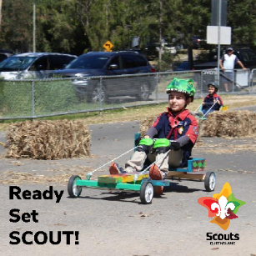  6pm Friday 29 January | Design it, build it, race it! In Scouts young people from 5 years old have the opportunity to try new things, learn whilst doing and have a whole lot of fun! #ReadySetScout #GoCarting #JoeyScouts
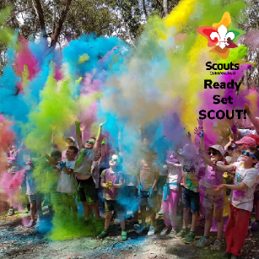  6pm Monday 1 February | Scouts is where we mix fun with education and develop stronger, more resilient young people! #ReadySetScout #ColourRun #CubScouts
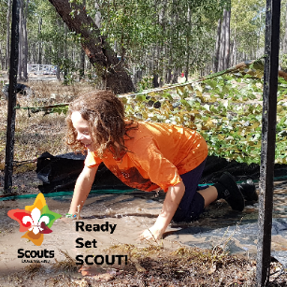  6pm Friday 5 February | Learn resilience, determination and leadership whilst having a blast in Scouts! #ReadySetScout #Mud #CubScouts
6pm Monday 8 February | No matter your passion, Scouts helps you chose your own adventure! #ReadySetScout #PerformingArts #Scouts
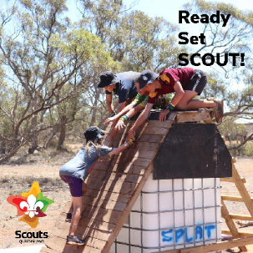  6pm Friday 12 February | Scouts learn how to work in teams to achieve incredible things! #ReadySetScout #TeamWork #Scouts
6pm Monday 15 February | Sail into endless possibilities with Scouts! We offer something for everyone ages 5 to 25! #ReadySetScout #Sailing #VenturerScouts
6pm Friday 19 February | Expand your horizons whilst making life-long friends, Scouting is the perfect after school hangout! #ReadySetScout #HighRopes #VenturerScouts
6pm Monday 22 February | Nothing comes between a Scout and an adventure, you never know where it will take you! #ReadySetScout #SCUBA #RoverScouts
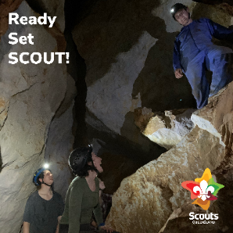  6pm Friday 26 February | Go beyond the horizon to places you never imagined with Scouts! For young people aged 5 to 25, the Scouting helps you reach even greater depths! #ReadySetScout #Caving #RoverScouts

